Activity 11 – Tipping Points: When the Climate Changes...
Rudolf Pausenberger and Moritz
Strähle
Will climate change at some point be unstoppable?
Background: Feedback and tipping points
When "tilting" with a chair, you can get yourself into a tilted position by pushing yourself against a table - the more you push, the more you can tilt. If you stop pressing against the table, you return to your starting position. But woe betide you if you push yourself off just a little too much...
Unfortunately, the Earth's climate system behaves in a similar way and could irrevocably collapse in the near future if even one gigatonne too many greenhouse gases are emitted.
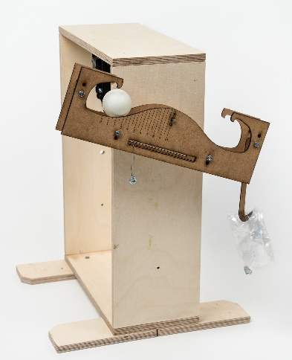
Materials:
- Connected wooden rails
- Wooden frame or tripod
Spacers made of Wwood
- Table tennis ball
- Sliding weight 50g
Screw with nut
- Sachet
Sliding weight
- 12 nuts (M6)

Experimental setup for modelling the tipping points in the Earth's climate system
Analogy:
Assemble the experiment as shown in the figure. The bag is empty for the time being and the weight is adjusted so that the structure (with table tennis ball) is in a horizontal position.
The position of the ball symbolises the state of the Earth's climate and how stable it is. The value x corresponds to the increase in the average temperature of the Earth compared to today. In its initial position, the Earth's climate is in a relatively stable state.
Now emit greenhouse gases by placing a nut inside the container and watch how the temperature on Earth (x-value) rises a little bit. One nut here corresponds to about 40 Gt CO₂, which is the global emission due to fossil fuels within one year.
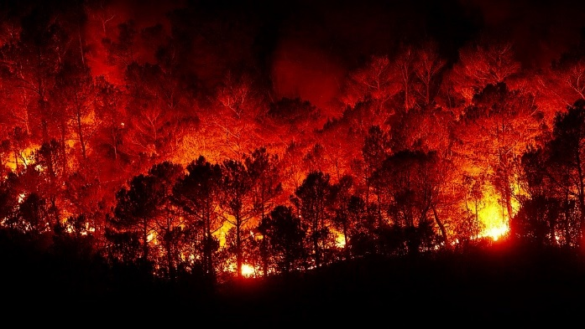
The devastating forest fires of 2019/20 in Australia have released about 30 Gt of CO₂. They were the result of an unusually long drought. The destruction of forests due to rising temperatures is an example of a tipping point: Climate change brings more pests, fires, storms and droughts. As a result, the Nordic forests in particular are collapsing. The CO₂ released then further accelerates climate change.
Forest fire (Source: Pixabay.de)

Experiment 1: Small cause, small effect
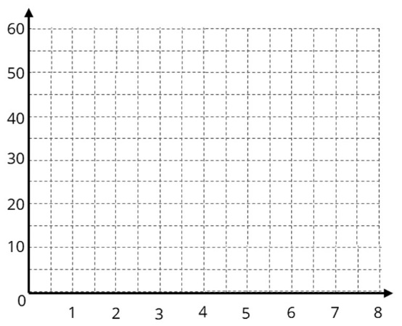
The relationship between the inserted nut and the position x of the ball is now to be examined more closely:
Deviation in mm / temperature increase
Number of nuts / emitted CO2
Place eight nuts one after the other in the container and enter the rest position of the ball in the diagram. How far is it from the beginning rest position at the end?
Note: If you think the ball is stuck, give it a light push and let it settle down again.
The ball is still on the left. Now take the nuts out of the container one by one (CO₂ is removed from the atmosphere) and mark the rest positions with a pen of a different colour and enter the values in the same graph.
What is the mathematical relationship in this experiment taking measurement errors into account?
Experiment 2: Small cause, big effect
We now examine the tipping point at which the system changes to another state.
Guess, without trying, from which position the ball will roll to the other side and how many nuts this corresponds to.
Check your assumption in the experiment. Gradually put nuts into the container until the air conditioning system tilts.
Now remove the added CO₂ from the Earth's atmosphere again (remove nuts from the bag).
Answer the following questions for evaluation:
Where is the actual tipping point compared to your estimated one?
Does the drastic rise in temperature decrease when the added CO₂ is removed from the atmosphere?

Tipping points are crucial to the catastrophic dynamics of climate change: When a tipping point is triggered, it is not immediately noticeable in reality, but a process is set in motion that is no longer reversible! An example: The ice on the Arctic Ocean reflects sunlight. If parts of the ice melt, more solar energy can warm the sea because of the lower reflection. The remaining ice then melts more quickly. At some point, the vicious circle can no longer be stopped. As in the game of dominoes, there is a cascade of tipping points in the Earth's climate system. One can trigger the next one at a time, making the temperature increase incalculable.

The Potsdam Institute for Climate Impact Research (PIK) scientifically addresses such tipping points. Search under "PIK tipping elements" (QR-Code) for more tipping points.

