Activity 12 – Tipping Points: Achilles' Heel in the

Cecilia Scorza



Climate System

What are tipping points and how are they connected?

Background:

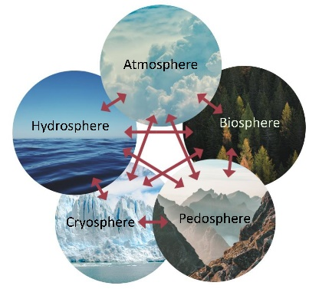The Earth's global climate system is determined by the *interaction* between the main components of the climate system: hydrosphere (water), atmosphere (air), cryosphere (ice and snow), pedosphere and lithosphere (soil and rock) and the biosphere (living organisms). Global warming sets processes in motion that influence and change these different elements in different ways. Some of these processes are *self-reinforcing: For example*, global warming leads to increased evaporation of water; and since water vapour is a greenhouse gas, it increases the temperature of the atmosphere, which in turn ­leads to increased evaporation of water. Because of these *self-reinforcing feedback processes,* when a certain threshold is exceeded, the Earth's climate system can enter the uncontrollable state of a hot period. This is known as a *tipping point*. "Tipping" fmeans that these changes, as they become more and more self-reinforcing, will then be unstoppable or irreversible. The environmental effects of tipping points are far-reaching and could endanger the livelihoods of many millions of people.

Materials:

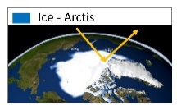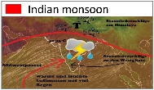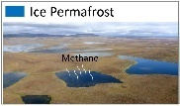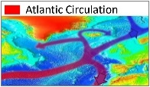

14 cards each: Illustrations (A) and explanations (B) of   
the tipping points

Implementation:

On the world map, tipping points and the affected parts of the climate system are shown in different colours: Ice bodies Flow Systems Ecosystems

Place the 14 cards with the illustrations of the tipping points (A) on the table and sort them by colour. Lay out the cards with the explanations and questions about the tipping points (B) on the right side.

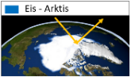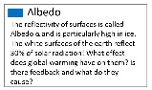

Match the cards (B) with the corresponding cards (A) and form the corresponding pairs. Start with the blue arctic map (A)!

Look at the world map again and answer the following questions with the help of the pairs of cards:

a) How does climate change alter the cryosphere (ice)?

b) How are the flow systems changing as a ­result of climate change?

c) How are ecosystems changing as a result of climate change?

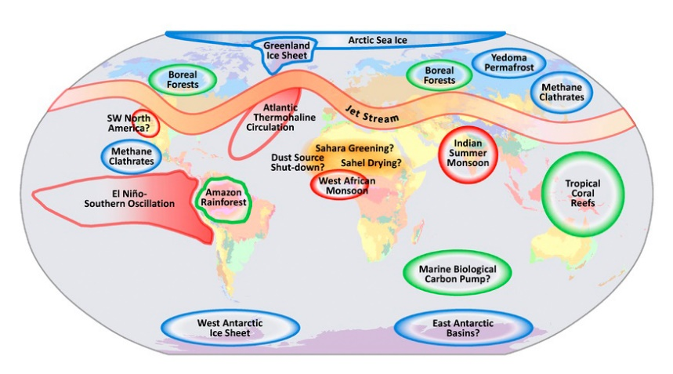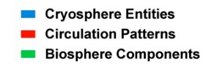

Geographical classification of tipping elements in the Earth's climate system (Source: PIK, 2007)