Activity 1 - The Earth in the Solar System
What makes our Earth a habitable planet?
Cecilia Scorza
Background:

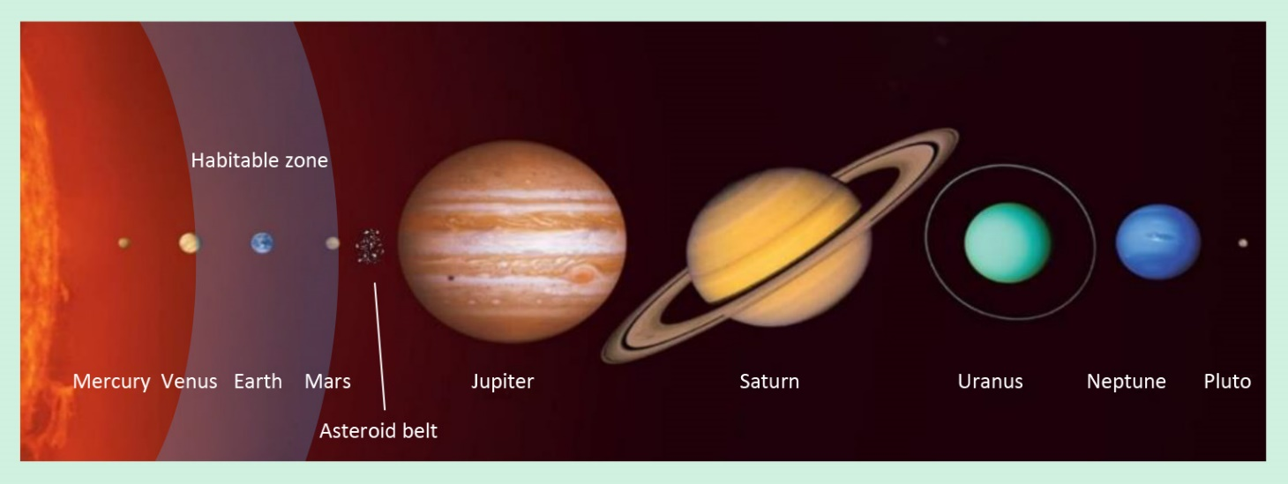
The Earth, like Mercury, Venus, and Mars, is one of the inner rocky planets of the Solar System. The inner rocky planets are followed by the asteroid belt (with about 650,000 asteroids) and the four gas giants Jupiter, Saturn, Neptune and Uranus as well as many dwarf planets such as Pluto. Around all stars, and thus also around our Sun, there is a so-called habitable zone - an area where water can exist in liquid form. The Earth and Mars are situated in the habitable zone, but only the Earth is habitable. Why?
The planets of our solar system in scale. The distances between the planets, however, are shown here clearly too small! (Credits: Scorza)
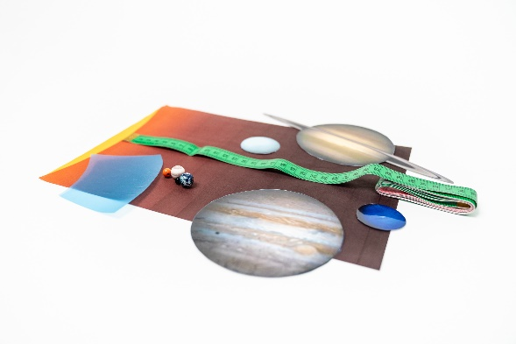
Materials:
Materials for the activity
Background image with an outline of the Sun
Planet models made of wood (rocky planets)
Laminated gas planets, cut out individually
Habitable zone (blue transparent film)
Measuring tape
Implementation:
Part 1: Where is the Earth located in the Solar System?
The distance from the Sun to the Earth is about 150 million km (this distance is defined as the Astronomical Unit (AU)). In our model, we compress this distance to 10 cm. The radius of the bright yellow disc thus corresponds to 1 AU. The habitable zone in our Solar System model is represented by the 6 cm² blue transparent film.
Detail of the Sun (Credits: Scorza)
Enter the distances of the planets to the Sun and the position of the habi-table zone into the table.

Planet | Distance from the Sun in AU | Distance in the model in cm
Mercury | 0.4
Venus | 0.7
Earth | 1.0 | 10
Mars | 1.5
Jupiter | 5.2
Saturn | 9.5
Uranus | 19.2
Neptune | 30.1
Habitable zone  (inner edge) | 0.85

Place the light-yellow disc on the floor and place the planetary spheres, the habitable zone, and the gas giants at the correct distance along a line on the floor.
Note: The planets are shown much too large compared to the
distances in this model! However, the scale of the planets to each other is correct.

Part 2: What role does mass play in the habitability of the Earth?
Where is the Earth model located in relation to the habitable zone?
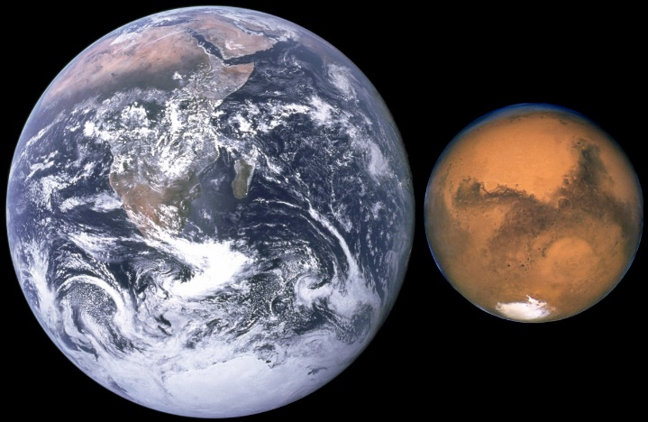
Now place Mars on the spot of the Earth. Discuss whether Mars would then be habitable. Compare the mass of Mars ($6.4⋅{10}^{23} kg$) with that of the Earth ($5.9⋅{10}^{24} kg$) and consider how the density of a planet's atmosphere is related to its mass (and gravity). Think of our Moon ($m=7.35⋅{10}^{22}kg$). Is there an atmosphere there?
Comparing Earth and Mars (Credits: NASA)

