Activity 2 – The Earth is irradiated
Part 1: Why is the Earth not getting hotter and hotter,
even though it is constantly exposed to the Sun?
Moritz Strähle and
Cecilia Scorza
Background:

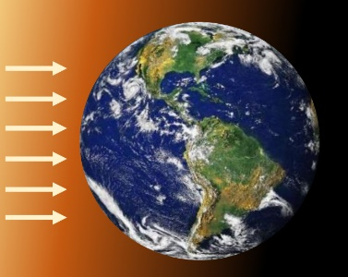
When a cool body is heated by supplying radiant energy, the body itself irradiates more and more energy in the form of thermal radiation. At some point, it absorbs the same amount of energy per second as it irradiates itself - it is then in radiative equilibrium and has reached the equilibrium temperature. Like all planets in the Solar System, the Earth is irradiated by the Sun. Is the Earth in radiative equilibrium?

Materials:
Spotlight
Small wooden Earth globe
1 digital thermometer
Stop watch
Implementation:
Take the Earth model and insert the digital thermometer into the small opening on one side. Place the earth directly under the radiator so that it is irradiated with the highest intensity.
Measure the temperature of the Earth every 30 seconds and note the results in a table.
Time s | 0  30 | 60  90 | 120  150 | 180  210 | 240  270 | 300  300 | 330 | 330 | 360 | 360 | 390 | 390 | 420 | 420 | 450 | 450
T Earth in °C

Display the results graphically in the diagram:
Equilibrium temperature $T_{EQ}=$
$$t in s$$
$$T in °C$$

Discuss your results and explain why the temperature of the Earth model does not continue to rise. Use the two figures below for your discussion and interpretation. Use the terms equilibrium temperature and radiation equilibrium.

Venus is closer to the Sun than the Earth. What would happen to the temperature on Earth if it were moved to the location of Venus (or Mars)?
Venus Earth Mars

Part 2: What role do ice surfaces play in the temperature of the Earth?
Background:
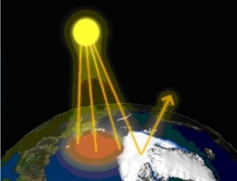
Bright surfaces on the Earth, such as ice and snow, reflect the incident light of the Sun more strongly than, for example, water or the ground. This reflectivity of a surface is called albedo $α$ (lat. "white"). For the Earth applies $α=0,3$. This means that 30 % of the incident radiation energy is reflected and does not contribute to heating. The loss of white space due to global warming has devastating effects on the Earth's climate.
Albedo of the Earth
Materials:
Experiment on the Albedo
- Spotlight
- 2 paper bodies (printed as rock or ice surface)
- 2 digital thermometers
- Stop watch
Implementation:
The two thermometers are inserted into the folded paper bodies. One represents the rocks under a melted glacier, the other an intact ice surface. Both test bodies are placed under the switched-on spotlight so that they are irradiated with the same intensity.

Measure the temperature of the two paper bodies every 30 seconds and note the results in the table.
Time in s | 0 | 30 | 60 | 90 | 120 | 150 | 180 | 210 | 240 | 270 | 300
Temperature
Black in °C
Temperature
White in °C

Display the results graphically in the diagram. Use different colours.
$$t in s$$
$$T in °C$$

Discuss your results and explain the different temperature curves. Use the terms albedo, equilibrium temperature and radiation equilibrium.
Discuss the effects of melting ice and glaciers on the temperature of the Earth. What are the effects of the current melting of the polar ice caps?

