Activity 3 – The Earth, a Radiating Planet
Cecilia Scorza and
Moritz Strähle
Part 1: Can we make the heat radiation of the Earth visible?
Background:
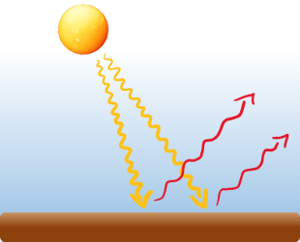
Energy is transported from the Sun to the Earth via electromagnetic waves. The largest part of solar radiation consists of short-wave electromagnetic waves (the light visible to us), which reach the ground almost without hindrance from the atmosphere, where they are then absorbed to a large extent. The ground of the Earth then radiates this received solar energy as heat radiation in the form of long-wave infrared radiation towards space. In total, the earth absorbs as much solar energy as it radiates into space as thermal radiation - it is in radiative equilibrium. The heat radiation of the earth is invisible to us. Can it be made visible and can it be researched?
Short wave solar radiation (yellow) and long wave infrared radiation (red). (Credits: Scorza, rays)

Materials:
Thermal imaging camera

Implementation:
Not only the Earth, but all bodies radiate heat away. The warmer a body is, the more intensive this radiation is. Observe people with and without glasses with the thermal imaging camera. What can you observe? Which parts of the face are warmer, which colder?
Heat radiation can also be felt! Feel carefully next to a cup of warm tea or another hot body; also observe with a thermal camera.
Rub your palms firmly together for five seconds and then press them on the table for five seconds. After removing your hands from the table, look at the contact surface with the thermal imaging camera. Explain how the image is created and why it disappears again. Rub the floor with your feet. What do you see?
Make a connection between the fading of your handprint and the radiant surface of the Earth. Why doesn't the Earth cool down more and more?
Look at the following pictures a) of the Earth and b) of the Sun. Can you see what is shown in picture c)?
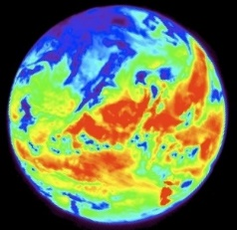
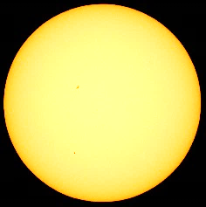
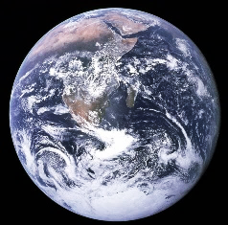

a) Earth b) Sun c) ?
Part 2: Which materials are transparent to visible light, which to infrared radiation?

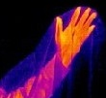
Background:
Visible light and infrared radiation have different properties. Some materials are transparent to infrared radiation (IR radiation) but not to visible light. Other materials absorb (i.e. trap) infrared radiation and allow visible light to pass through without hindrance. We explore these properties ourselves.
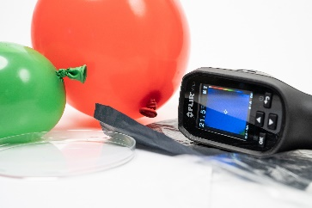
Various materials for
exploration of IR radiation
Materials:
- Thermal imaging camera
- Black garbage bag, paper, air-filled balloon, water-filled balloon
- Petri dish made of glass

Use your hand as an infrared radiator and your eyes or the thermal imaging camera to examine the permeability of different materials and complete the table:
Material | Permeable for IR radiation | Permeable for visible light
Glass
Black bag
Paper
Air-filled balloon
Water-filled balloon
Textbook
Cling film

The greenhouse gases in the atmosphere allow visible light to pass almost without hindrance. However, they absorb infrared radiation. Which of the above explored materials also exhibits these properties?

