Activity 4 – The Keys of the Earth’s temperature
Moritz Strähle and
Cecilia Scorza
What influence do greenhouse gases have on the Earth's temperature?

Background:
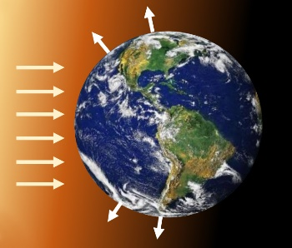
On average, the Earth's surface is irradiated by the Sun with $340\frac{W}{m^{2}}$ (“watts per square metre”) in the course of one day. Approximately 30% of the solar radiation is reflected away into Space, for example by ice surfaces and white clouds; the remaining energy is absorbed (collected) by the Earth's surface and thereafter radiated away as invisible heat radiation (in the infrared). The amount of energy emitted is equal to the amount of energy received - the Earth, thus, is in radiative equilibrium.
The Earth is irradiated by the Sun and itself radiates
T?
Using the Stefan-Boltzmann law, we can now estimate the average temperature on Earth. The law describes the intensity of radiation $I$ (in Watt per $m^{2}$) which a body at a certain temperature $T$ radiates:
$$I = σ∙{T }^{4}$$
$σ$ (Sigma) is a constant that "translates" between temperature and intensity $σ=5,67⋅{10}^{-8}\frac{W}{m^{2}K^{4}}$.
The hotter a body is, the more radiation it emits, proportional to the fourth power of its temperature. So, if you double the temperature of a body, it radiates $2^{4} = 16$- times more energy per second! What temperature would prevail on an earth without atmosphere?
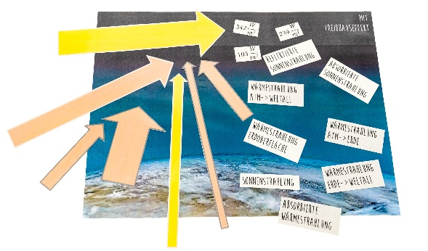
Materials:
- Arrows and labels for displaying
- A3 sheet: Earth with and without atmosphere

Part 1: What would be the average temperature
on an earth without atmosphere?
Implementation:
Placing arrows: Place the light grey bordered arrows and the light grey labels on the sheet "Earth without atmosphere" to match the background text.
In the diagram on the next page, you will find a graphical representation of the Stefan-Boltzmann law. We will now try to get familiar with it! First complete the missing temperature values in the table (estimate) and then enter them into the diagram. Now read the values of the corresponding radiation intensity of these objects in the diagram and complete them in the table as well. Follow the example of boiling water.
Object | Temperature °C | Intensity W/m²
Boiling water | 100 | 1100
Human body
Room temperature
Ice cubes
If you have placed and assigned the arrows and labels correctly, you will know that, on average, the Earth absorbs $238\frac{W}{m^{2}}$ of solar radiation and radiates this energy away again (radiation equilibrium). Now use the diagram inversely to determine the average temperature of an earth that radiates infrared radiation with this intensity and enter it in the diagram accordingly.
Interpret the result and compare it to reality: Is it possible to align the average temperature of the Earth you have determined with your experiences? What is the reason for this?
Not an easy additional question: Do you have any idea why it would be much colder on an earth without an atmosphere?
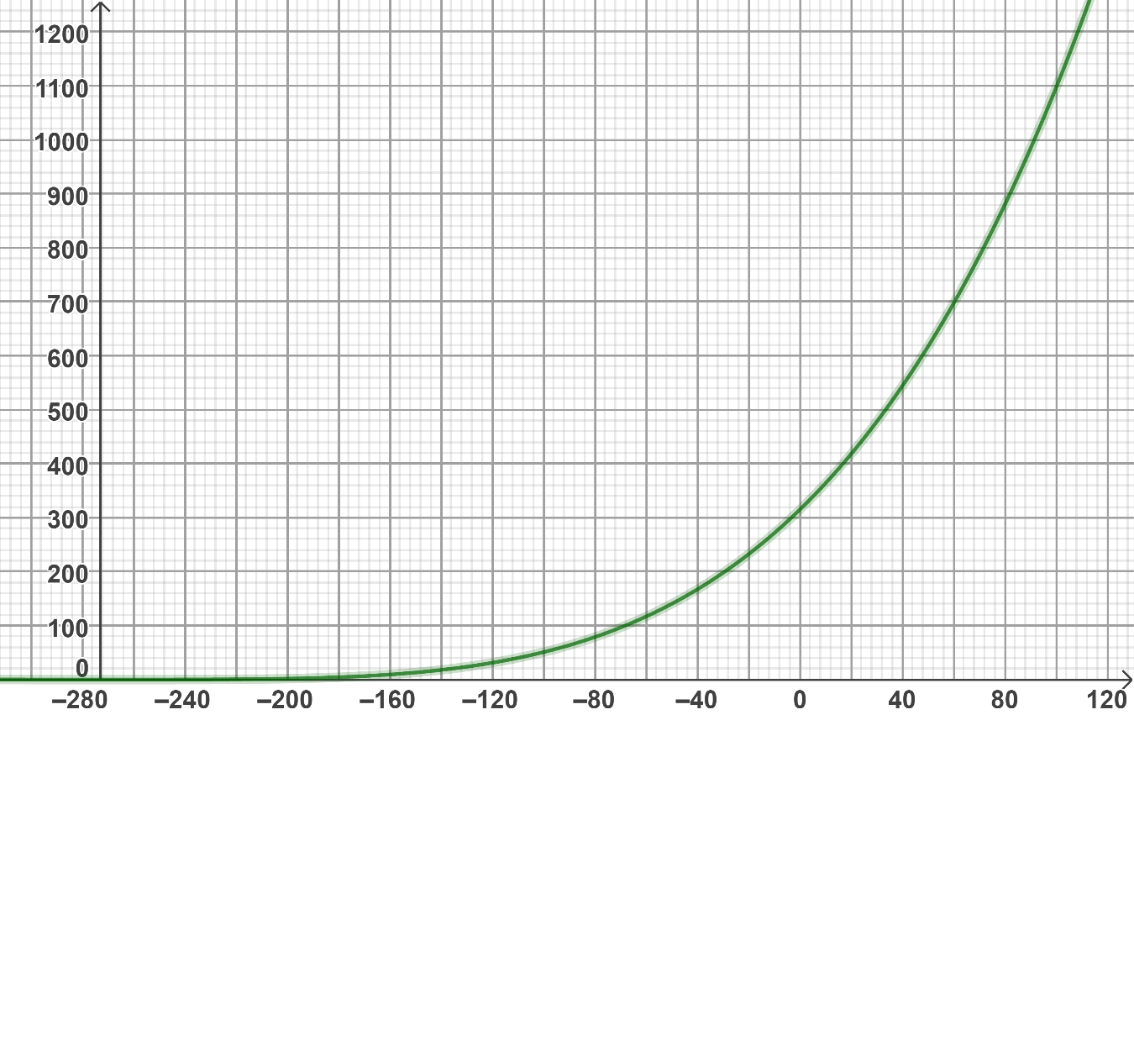
$$I \text{in} W/m^{2}$$
$$T\text{ in} °C$$
Boiling
Water
Representation of the Stefan-Boltzmann Law in a diagram.
Part 2: What temperature on Earth does the natural greenhouse effect cause?
Background:

Without an atmosphere, it would be very cold on Earth. But how does our atmosphere ensure pleasant temperatures on Earth? The light of the Sun can pass the atmosphere almost without hindrance. Moreover, we assume that the Earth's surface is irradiated by the Sun on average with $340\frac{W}{m^{2}}$, 30% of which is directly reflected back into Space and the rest is absorbed by the Earth's surface. In the following, we assume that 76% of the heat radiation emitted by the heated surface of the Earth is absorbed by the atmosphere; the rest (24%) goes unhindered into Space. The atmosphere heated by this absorbed heat radiation now in turn also radiates heat radiation - half towards Space, the other half towards the ground.
Earth with atmosphere
Implementation:
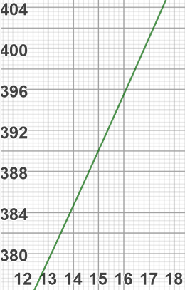
Laying arrows: Study the background text and lay out the light grey and dark grey bordered arrows on the "Earth with atmosphere" sheet.
$$I \text{in} W/m^{2}$$
$$T\text{ in} °C$$
The atmosphere is thus (in addition to the Sun) a second source of radiation, which (with our assumptions) emits radiation with an intensity of $147\frac{W}{m^{2}}$ towards the ground. This energy is now additionally absorbed by the ground, which radiates again with greater intensity. What is the value of this radiation intensity and what is the temperature of the ground for this? Use the diagram on the right, which is an enlargement of the diagram above.
Hint: Add up the two radiation intensities absorbed by the earth.

Part 3: How strong is the anthropogenic greenhouse effect?
Background:

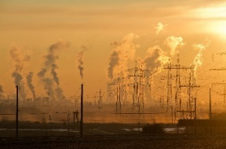
The natural greenhouse effect ensures pleasant temperatures and that life can exist on Earth at all! But now humans come into play: Due to the strong emission of greenhouse gases such as carbon dioxide or methane, an increasing proportion of the Earth's infrared radiation is absorbed by the atmosphere.
Greenhouse gas emissions

In the following example, we assume that the atmosphere absorbs slightly more radiation from the Earth: 78% instead of 76%. As a result, it heats up more and therefore also radiates with higher intensity. In this case, this would correspond to an additional $6\frac{W}{m^{2}}$. What is the average temperature for the Earth with this additional energy source, that irradiates the Earth?
Info: The Intergovernmental Panel on Climate Change (IPCC) uses computer models to provide scenarios (possibilities) for the future climate. The scenarios vary from RCP 2.6 to RCP 8.5, with the figure indicating an additional radiation intensity of $2,6\frac{W}{m^{2}}$ respectively $8,5\frac{W}{m^{2}}$ from the atmosphere towards the Earth's surface.

