Activity 6 – The Rise in Sea Level
Cecilia Scorza
and Moritz Strähle

How does climate change lead to a rise in sea level?
Background:
Due to global warming, large masses of ice are currently melting on land, such as the Greenland ice sheet or glaciers in the Alps. The water temperature of the oceans is also rising. This also means that icebergs floating in the water are melting faster.
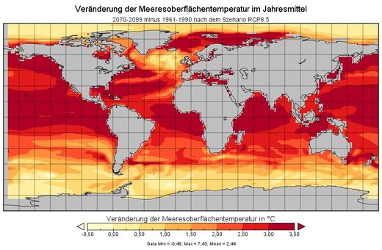
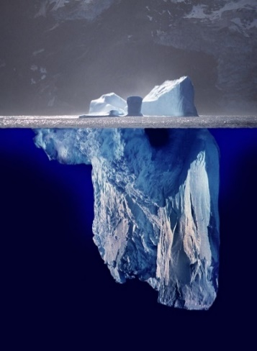
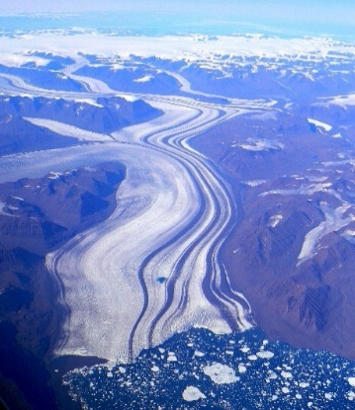
Photomontage of an iceberg
(Credits: Uwe Kils)
Glaciers on Greenland
(Source: Wikipedia)

Comparison of the mean temperature 2070-2099 compared to 1961-1990 in scenario RCP8.5 (source: wiki.bildungsserver.de)
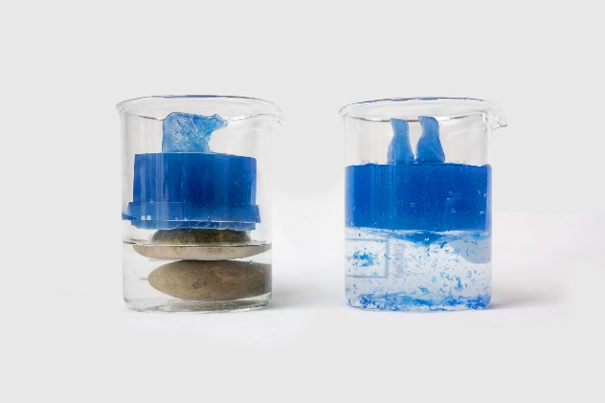
Materials:
Experiments on sea level rise
Spotlight
Two 150ml beakers
Ice cube penguin and polar bear
Two flat pebble stones
Water-soluble felt-tip pen
Erlenmeyer flask
Rubber stopper with glass tube
Experiment 1: Is sea level rising due to melting icebergs?
Place the stones in one of the beakers. Fill up this beaker so that only the first stone is under water and fill the other the other with approx. 80 ml of cold water. Then place one ice cube on the stones, let the other one float in the other beaker and place the beakers under the spotlight. Mark the water level with the water-soluble felt pen instantly! Continue with the next experiment.
Experiment 2: Is the sea level rising due to the warming of the water?
Fill the flask with water and close it with the rubber stopper and glass tube so that the water in the tube is halfway up and no air bubbles form (some tests may be necessary).
Mark the level with the water-soluble felt pen and heat the water in the flask with your hands for a few minutes. Watch the ice cubes while doing so.
Write down your observations in both experiments and describe in a short summary why sea levels are rising (and why they are not) due to global warming. Also refer to the pictures in the background text and the results of the experiments.

