Activity 7 – Climate Zones and Climate Change
Cecilia Scorza
and Moritz Strähle

How do the Earth's climate zones develop and what
impact does climate change have on their expansion?
Background:
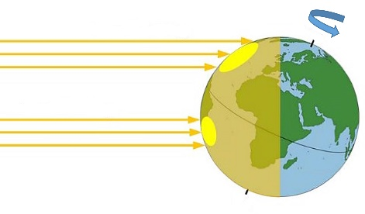
The climate zones of the Earth are created by the difference in intensity of solar radiation depending on the geographical latitude. Near the equator, the angle of incidence of the Sun's rays is relatively high all year round and at certain times even perpendicular to the Earth's surface. With increasing geographical latitude, the Sun's rays reach the Earth's surface at an increasingly flat angle, so that the irradiated energy is distributed over a larger area (see figure).
Angle of incidence of the Sun's rays in relation to the geographical latitude
(Source: denkwerkstatt-physik.de)
Flat radiation
Steep radiation
The seasons are created by the inclination of the Earth's axis of 23.5° relative to the orbital plane of the Earth around the Sun, the so-called ecliptic. Thus, the northern hemisphere tends to tilt towards the Sun in summer and away from it in winter. (In the figure, the northern hemisphere is in winter.)

Part 1: How do climate zones develop?
In this experiment you will learn about the relationship between the angle of incidence of the Sun and the climate zones and how climate change affects them.
Angle of incidence and intensity
Materials:
Spotlight
Solar cell with fan
Earth globe (optionally)
Implementation:
Take the solar cell with the connected fan. The speed of rotation indicates how high the incident light intensity is. The spotlight represents the Sun.
Switch the spotlight on and align the solar cell on the opposite edge of the wooden frame in the direction of the spotlight.
Now change the inclination angle of the solar cell and make a qualitative note of the rotation speed for the following angle positions:
Rotation speed at 90°: 45°: 0°:
Summarise the test result in one sentence.

Evaluation:
The left figure shows the annual mean value of solar radiation at the top of the atmosphere in the unit W/m². The right figure shows the division of the Earth into our five main climate zones.
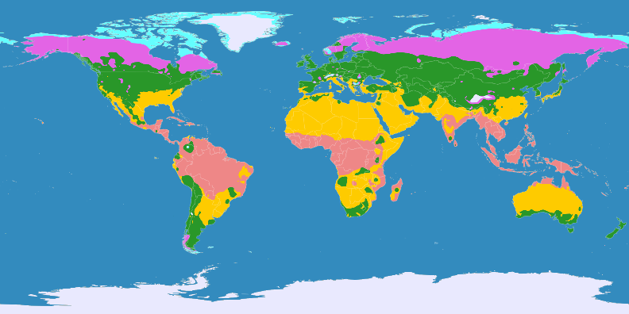
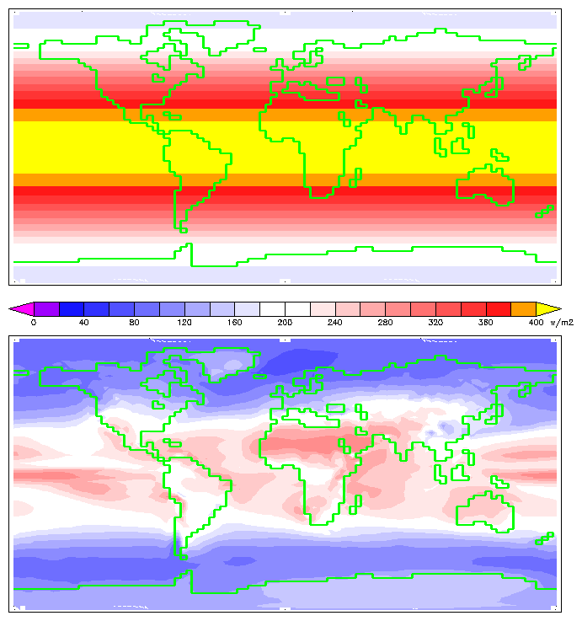
On the left: Annual average solar radiation on top of atmosphere; Right: Genetic climate classification
(Source: left: Wiliam M. Conolley]; Right: https://upload.wikimedia.org/wikipedia/commons/thumb/9/9c/Klimag%C3%BCrtel-der-erde.svg/2880px-Klimag%C3%BCrtel-der-erde.svg.png)
2
4
1
5
3

Assign the following climate zones to the numbers 1 to 5 and give approximate values of average solar radiation for each zone: Subpolar zone, subtropical zone, temperate zone, polar zone, tropical zone
Number | Climate zone | Average solar radiation in W/m²
1)
2)
3)
4)
5)

Explain briefly the connection between the left and the right figure above.
Part 2: Impacts of climate change on climate zones and ecosystems
Follow the QR Code and read the article on the consequences of climate change on climate zones and the animals living there.

Evaluation:
Describe the consequences of climate change on the Earth's climate zones.
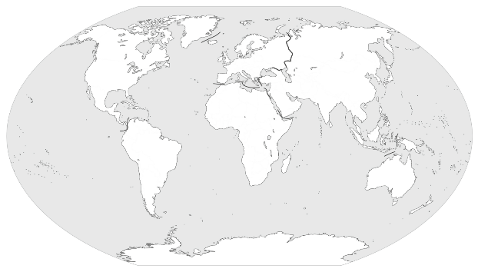
What are the consequences of climate change on animal habitats and what problems does it pose?
Silent world map (source: https://media.diercke.net/omeda/89090__Erde_Kontinente_und_Ozeane.pdf])
Future scenario: Outline a possible global distribution of climate zones in 2100 in the silent world map below. Colour the climate zones according to the marking in Fig.2.

