Activity 8 – The Oceans as a Climate Buffer
Cecilia Scorza
and Moritz Strähle
How do the oceans protect us from even greater climate change?
Background:
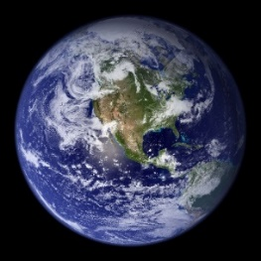
About two-thirds of the Earth's surface are covered with liquid water and this has an impact on the Earth's climate. This is because water is a very effective heat store: A certain mass of water can absorb significantly more energy per Kelvin temperature increase than, for example, the same mass of air. For example, one kilogram of water heats up with an energy supply of $4.2 kJ$ at $1 K$. Water therefore has a heat capacity of $4,2\frac{kJ}{kg⋅K}$. Air and dry Earth, on the other hand, have a heat capacity of approx. $1\frac{kJ}{kg⋅K}$. Thus, about one kilojoule is enough to warm up one kilogram of these substances by $1 K$.
Our blue Earth (NASA)
The man-made greenhouse effect provides the Earth's surface with additional energy. How does the water in the oceans affect global warming?
Materials:
Water-filled balloon over a candle
Balloon filled with water
Candle and match
Implementation:
How close do you dare to hold the water-filled balloon over the candle? Approach the flame slowly!
Touch the balloon from below after some time. Has it warmed up a lot?
Evaluation:
Read the background text and explain your observations.
The man-made greenhouse effect adds extra energy to the atmosphere. Explain why without our oceans the impact would be even more drastic than it already is today. Which of these two Earths would have a higher surface temperature?
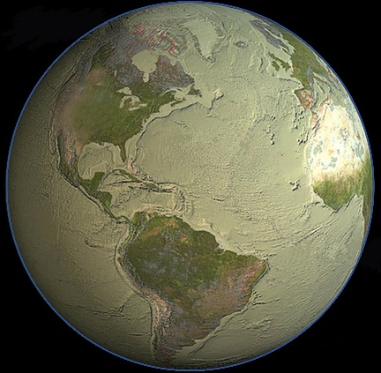
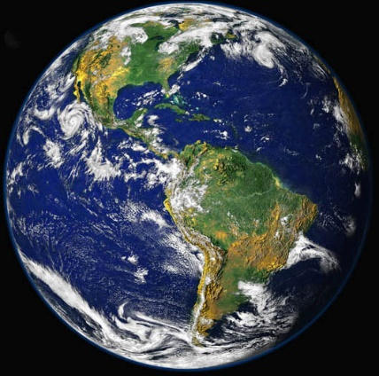
Dry Earth (Credits: Cook, Nieman, USGS)
The blue pearl (Credits: NASA)

