Activity 9 – The Acidification of the Oceans
Pascal Eitner, Markus
Vogelpohl and Clemens Bröll

Why does CO₂ make the oceans acidic and what are
the consequences?
Background:

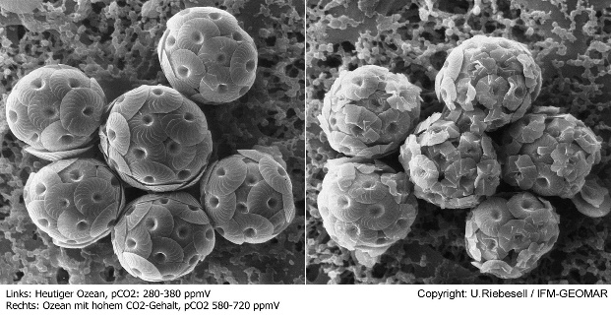
Measurements of the pH value in the oceans show an increasing acidification of the water. If the content of the greenhouse gas CO₂ in the Earth's atmosphere rises (for example due to the burning of fossil fuels), it will also increasingly be dissolved in seawater, where it chemically reacts to carbonic acid (H₂O + CO₂ ⇌ H₂CO₃). This has fatal consequences for the life of algae and animals living there, which are not adapted to the increasingly acidic environment. In addition, the shells of calcareous algae, for example, become thinner (see figure) and corals lose their calcareous skeleton. The CO₂ fixing of the oceans is decreasing overall.
Calcareous algae: on the left side today's ocean, on the right side ocean with high CO₂ content. [Source: IFM-GEOMAR]
Materials:
Experimental setup
- Two 50 ml beakers
Universal indicator with pH-value chart
Citric acid, sodium bicarbonate and water
Erlenmeyer flask with rubber stopper and tube

Implementation:
Put 50 ml of water into a beaker and add 15 drops of the indicator until the solution changes its colour significantly.
Note the pH value of the solution.
Pour half of the solution into the second beaker.
Mix one teaspoonful each of citric acid and baking soda in the Erlenmeyer flask, then carefully add some water and conduct the resulting CO₂ (carbon dioxide) with the tube into the water in the second beaker (see illustration).
Do not pour away:
You need the solution in the second beaker for activity 10!
Note the pH value of the solution in the second beaker.
Describe the test result in one sentence!
Evaluation:
Answer the following questions with the help of the background text for Experiment 1 and with an internet search under the QR code shown on the right:
To what extent do oceans seem to contribute to a slowdown of the man-made greenhouse effect?
What consequences does acidification of the oceans have for its creatures?

