Everybody’s Darling: Energy
#energy #storage size #energy forms #energy conversions
Understanding Energy - Worksheet 1 - Page 1 of 2
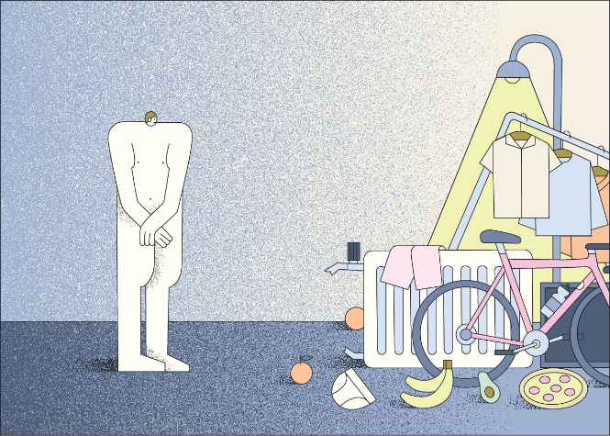
- Describe situations or aspects of everyday life in which energy plays a role and name the associated form of energy.
 | Situation / Everyday life | Form of Energy
 | Example: Energy through food | Chemical energy

- The following chart shows the average energy demand per person per year. Estimate which range is shown here in each case and complete the table. Use a pencil.

Color | Situation/ everyday life | Energy source | Form of energy provided | Machine | Usable form of energy
 | Heating
 | Everyday trips (mobility)
 | Vacation trips (mobility)
Example:  grey | Cooking, cooling | Electricity | Electrical energy E _{el} | Stove, refrigerator | thermal energy  W _{th}
 | Hot water

- Here you can see the energy demand per person and day of some countries.
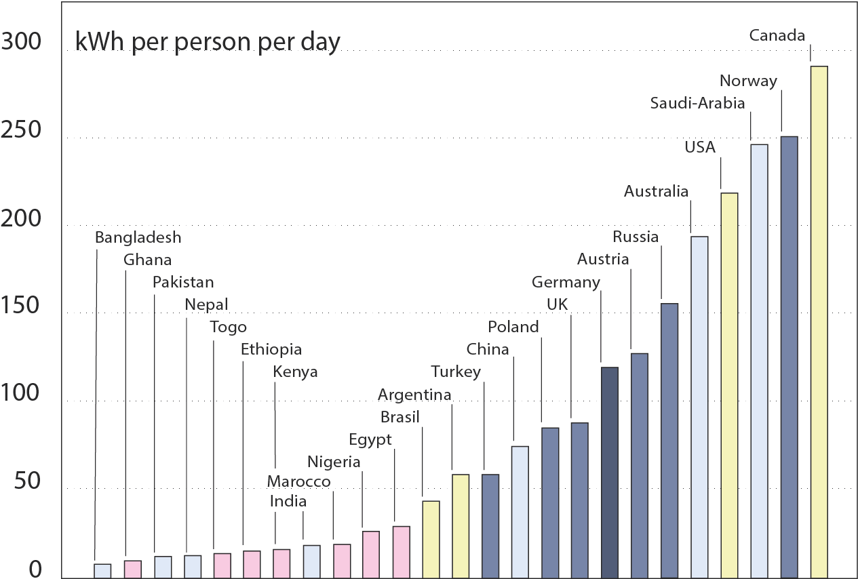
a) How do you rate Germany in international comparison?

Understanding Energy - Worksheet 1 - Page 2 of 2

b) Why do countries such as Norway or Saudi Arabia, for example, have less of a problem with their very high energy requirements compared to Germany?

- From 2008 to 2019, the energy demand for "air conditioning cooling" has increased by 40%.

- Complete the table.
Situation/ everyday life | Energy source | Form of energy provided | Machine
Cooling

- Will this trend continue? Give reasons for your opinion.

- List, in bullet form, various measures that cities and towns, or specifically our school, are using to reduce the heating of buildings.

- Humans can also be seen as "machines". Complete the table.
Situation/ everyday life | Energy source | Form of energy provided | Machine | Usable form of energy
Human |  |  | Human

- Think about what both your body and technical devices do with the supplied energy and deduce a basic property of energy!

Everybody’s Darling: Energy – Solution
Solution for Understanding Energy - Worksheet 1 - Page 1 of 2

- Describe situations in everyday life in which energy plays a role and name the corresponding form of energy!
Situation / Everyday life | Form of Energy
Example: Energy through food | Chemical energy
e.g. : Energy through hot water bottle | Heat energy
Energy by driving a car | E_{chem} E_{kin}
Energy through electricity for light... | E_{el} E _{Radiation} E_{el} W _{th}

- The following chart shows the average energy demand per person per year. Estimate which range is shown here in each case and complete the table. Use a pencil.
Other in household
Pets
Food
Clothing

Color | Situation/ everyday life | Energy source | Form of energy provided | Machine | Usable form of energy
blue | Heating | Gas, Oil | E _{chem} | Heating / Gas boiler | W _{th}
green | Everyday trips (mobility) | Gasoline, diesel, electricity | E _{chem} | Car engine | E _{kin}
red | Vacation trips (mobility) | gasoline, diesel, electricity, kerosene | E _{chem} | Car engine, airplane engine | E _{kin}
Example:  grey | Cooking, cooling | Electricity | Electrical energy E _{el} | Stove, refrigerator | thermal energy  W _{th}
orange | Hot water | electricity, gas, oil, solar radiation | E _{chem}  E _{Radiation} | Kettle, boiler, heater, gas boiler... | Thermal energy W _{th}

- Here you can see the energy demand per person and day of some countries.
Solution for Understanding Energy - Worksheet 1 - Page 2 of 2
By international comparison, Germany has a relatively high energy requirement per person.

Only in a few countries is this energy demand per person even higher, albeit in some cases very significantly so.
a) How do you rate Germany in international comparison?

b) Why do countries such as Norway or Saudi Arabia, for example, have less of a problem with their very high energy requirements compared to Germany?
These countries have a lot of energy sources available.
Norway: Water; Saudi Arabia: Oil

- From 2008 to 2019, the energy demand for "air conditioning cooling" has increased by 40%.
- Complete the table.
Situation/ everyday life | Energy source | Form of energy provided | Machine
Cooling | electricity | E _{el} | air conditioner

- Will this trend continue? Give reasons for your opinion.
Due to climate change, hot spells will become longer and more intense.
- Demand for cooling will increase.

- List, in bullet form, various measures that cities and towns, or specifically our school, are using to reduce the heating of buildings.
Curtains, blinds, awnings, plants, water points, power saving? ...

- Humans can also be seen as "machines". Complete the table.
Situation/ everyday life | Energy source | Form of energy provided |  | Machine | Usable form of energy
Human | Food | E _{chem} | Human |  | E _{kin} W _{th}

- Think about what both your body and technical devices do with the supplied energy and deduce a basic property of energy!
Energy can be converted into other forms of energy.

Everybody’s Darling: Energy – Notes
Notes for Understanding Energy - Worksheet 1

These tasks can be used as an introduction to the topic of "energy".
- • Other examples: Light sources (E _{Radiation}), Energy through food (E_{chem}), energy to do sports (E_{kin}), energy to heat (W_{th}), energy to make clothes (E_{chem})…
- Possible discussion about energy and forms of energy.
- Purposes of this task:
- Name forms of energy
- recognize that energy can be converted into each other
- Information about what we need energy for and what the corresponding proportions are.

Further Information:
- Other energy in the household: energy for washing, drying, media, lighting, sauna...
- Energy for food: energy necessary for production (fuel, fertilizer...)
- The graph shows the average energy demand per person. This varies extremely depending on income and social milieu. For example, the energy demand for incomes below 1000 euros is $11574 kWh/a$, while that for incomes above 3000 euros is $19 853 kWh/a$, almost twice as high. For vacation trips, the energy demand ranges from $411 kWh/a$ to $2540 kWh/a$ depending on income (Source: https://www.umweltbundesamt.de/publikationen/repraesentative-erhebung-von-pro-kopf-verbraeuchenf )
- One could use this fact for further discussions

- Supplement:
Countries with very high energy consumption often also have very high per capita incomes.

- c) Due to the high specific heat capacity of water, water points serve as a natural heat buffer. Heat buffer in that water heats up more slowly than, for example, stones. Water can contribute to cooling to a certain extent through evaporation energy. The purpose of saving electricity is to convert less electrical energy into heat energy. Although electricity saving primarily refers to appliances with high power (oven, stove, ...), it also applies to appliances that can contribute to heating with a high average heat energy due to their continuous operation (e.g. freezer) or their frequent occurrence in the household (appliances in standby mode). Potential for discussion!
- Outlook:
- Possible discussion about the daily energy requirement (for men approx. 3000 kcal).
- Possible connection to interdisciplinary projects

