Everybody’s Darling: Energy
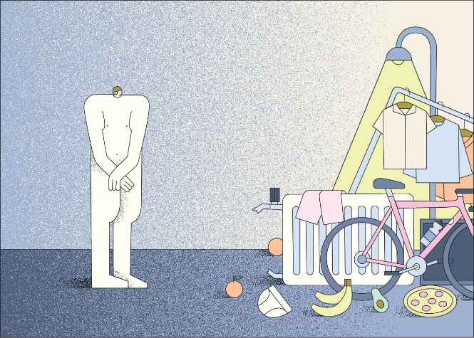
- Describe situations in everyday life in which energy plays a role! Also name the corresponding form of energy! If necessary, use material 1 to help you!
- Material 2 shows the average energy consumption per capita and year.
- Assign the individual shares (blue, orange, red and green) to the different areas! Enter the colors in the table (material 3).
- Then complete the table below by adding a provided form of energy, the respective energy source, a required form of energy and an example for a used machine. Partly there are different possibilities.
Material 1 Forms of energy
- Consider in which areas one still needs energy! To which areas do the unassigned colors belong? Compare with the solution or ask your teacher!

Material 2 Energieverbrauch pro Person im Jahr
Color in the graphic | Areas | Form of energy provided | Energy source | Machine | Usable form of energy
 | Heating
 | Everyday trips (mobility)
 | Vacation trips (mobility)
grey | Cooking, cooling | Electrical energy | Electricity | Stove, refrigerator | Thermal energy
 | Hot water
Material 3 Table
- Material 4 shows the energy consumption per person and day of many countries. Find Germany and formulate in one sentence how you rate Germany in international comparison! Think about why the very high energy consumption is less of a problem for countries like Norway or Saudi Arabia than for Germany!
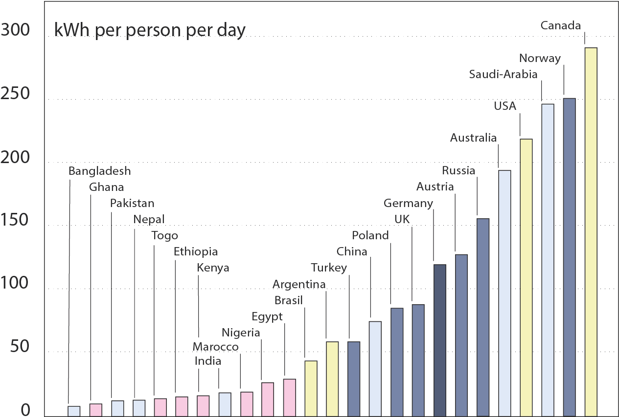
M 4 Energy consumption per capita in comparison
From 2008 to 2019, the energy demand for air conditioning has increased by 40%.
Think about the form of energy needed and the machines used for it. Give reasons why this trend is likely to continue!
Do you know of measures that cities and towns or our school are using to reduce the heating of buildings?
- Humans can also be seen as "machines." Identify the form of energy provided and usable.
- Describe what your body and technical devices do with the supplied energy and deduce a general property of energy!

Solution and notes for the worksheet Energy
These tasks can be used as an introduction to the topic "Energy".
Solutions
- For example: energy for light, energy for food, energy for sports, energy for heating, energy for making clothes...
Here a general discussion about energy and forms of energy is useful.
Kinetic energy
Chemical energy: energy in food, in gasoline....
Heat energy, light energy
This is a general discussion about energy and forms of energy.
Reference to the book: p.12-14

Color in the graphic | Areas | Form of energy provided | Energy source | Machine | Usable form of energy
blue | Heating | Chemical energy | Gas | Gas boiler | Thermal energy
green | Everyday trips (mobility) | Chemical energy | Gasoline engine | car | Kinetic energy
red | Vacation trips (mobility) | Chemical energy | Gasoline engine | car, airplane | Kinetic energy
gray | Cooking, cooling | Electrical energy | Electricity | Stove, refrigerator | Thermal energy
orange | Hot water | Chemical energy | Gas, oil | Gas boiler, oil heating | Heat energy

The purpose of the task is, on the one hand, to name forms of energy and to recognize that energy can be converted into each other and to achieve these learning objectives. At the same time, this task offers an opportunity for the students to become aware of what we need energy for and how large the corresponding proportions are.

Additional information:
- Other household energy includes: Energy for washing and drying, for media, for lighting, and for sauna.
- Energy for food includes energy required for production, such as fuel, fertilizer, etc.
- The graph shows the average energy consumption per person. Energy consumption varies extremely depending on income and social milieu. For example, the energy consumption for incomes below 1000 euros is $11574 kWh/a$, while that for incomes above 3000 euros is $19 853 kWh/a$, almost twice as high. For vacation trips, the energy consumption ranges from $411\frac{kWh}{a}$ to $2540\frac{kWh}{a}$ depending on income. One could use this fact for further discussion

- German energy consumption per capita is very high. Countries with very high energy consumption have a very high per capita income or also very large deposits of energy sources such as oil/gas/hydroelectric power.

Areas | Form of energy provided | Energy source | Machine
Cooling | Electrical energy | Electricity | Air conditioning

The proportion will increase because heat periods will rise due to climate change. Possibilities to counteract this would be, for example, to build additional shading such as awnings, to plant more greenery or to add water areas.

Areas | Form of energy provided | Energy source | Machine | Useable form energy
Human | Chemical energy | Food | Human | Kinetic energy, thermal energy

Hint:
This question also provides an entry point to talk about daily energy needs (man about 3000 kcal) and provides connection to cross-curricular projects.
- The energy is converted.

https://www.umweltbundesamt.de/publikationen/repraesentative-erhebung-von-pro-kopf-verbraeuchenf, P.101-125
https://www.umweltbundesamt.de/publikationen/repraesentative-erhebung-von-pro-kopf-verbraeuchen, P.101-125

