Activity 5 – The Effect of Greenhouse Gases
What effect do greenhouse gases have on the Earth's temperature?
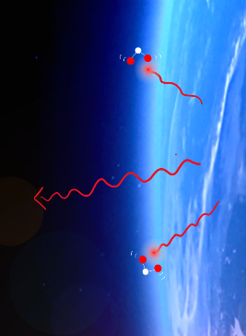
Background:

Absorption of IR radiation by greenhouse gases
The Earth's atmosphere consists mainly of nitrogen (78%) and oxygen (21%). Greenhouse gases such as carbon dioxide (0.04%) and methane (0.0002%) are only present in trace amounts, but nevertheless have a major impact! The molecules of the greenhouse gases absorb the invisible infrared radiation emitted by the Earth's surface and thus vibrate. This oscillation energy is then transferred to particles in the environment in the form of kinetic energy - the atmosphere warms up! What happens to the temperature of the atmosphere when people release large quantities of CO₂ into the atmosphere by burning fossil fuels?

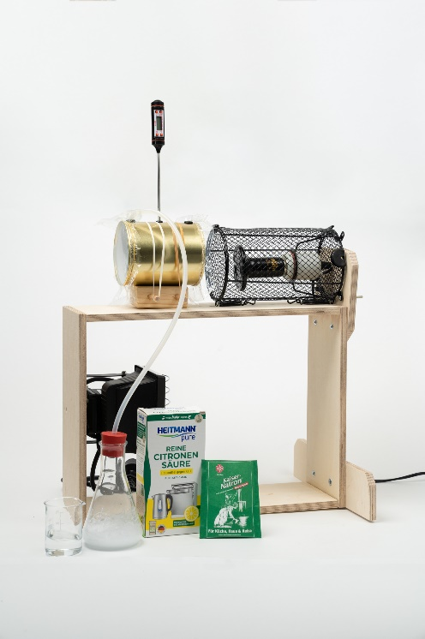
Part 1: Can CO₂ "intercept" invisible infrared radiation?
Model experiment for greenhouse effect
Materials:
Ceramic infrared radiator
Tin, stopper, cling film and rubber bands
Wooden block for plugging in and holding rubbers
Digital thermometer
Erlenmeyer flask with stopper and tube
Soda, citric acid and water

Preparation:
Screw the ceramic infrared radiator with the screws with
the feet of the wooden frame folded at the top (see picture).
Seal the open ends of the can with cling film and rubber bands. Insert the thermometer into the small hole in the middle and seal the two large holes (supply and outlet of CO₂) with a plug each. Then stretch the can with more rubber bands on the wooden block (see picture), so that the can has a distance of about 10 cm from the radiator.
Switch on the infrared radiator. As the emitter heats up, read the background text carefully and match the parts of the experiment with their equivalents in reality:
Air in the can Additional greenhouse gases
Ceramic infrared radiators Earth's atmosphere with normal CO₂ concentration
CO₂ produced in the Erlenmeyer flask Earth soil

Implementation:
Wait until the temperature in the can no longer changes in a time frame of 30 seconds and you can assume that the equilibrium temperature has been reached (in the range between 30°C and 40°C). Write this down!
Now create CO₂ and pour it into the can: Mix one teaspoonful each of sodium bicarbonate and citric acid in an Erlenmeyer flask (without water), remove the two plugs from the can, push the tube into the can, add a little water to the acid-sodium mixture and close it immediately!
Remove the tube after about one minute and close the holes with the plugs - the CO₂ concentration in the can is now increased significantly. Observe the measured temperature over the next few minutes and wait until an equilibrium temperature is reached again. Note its value and compare it with the value at normal CO₂ concentration in the air.
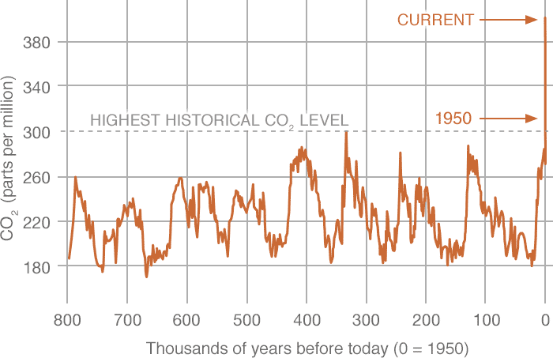
The CO₂ concentration in the atmosphere is measured in parts per million (ppm). It thus indicates how many molecules of CO₂ one million molecules of dry air contain. Search the Internet for "NASA CO₂" and search for the current CO₂ concentration in the atmosphere. Also compare with the historical values of the last 800,000 years in the figure there.
What has led to the observed greenhouse gas concentration since the 19th century? How is the experiment related to these data? Summarise your findings in two sentences.

Part 2: Infrared radiation is intercepted
In addition to measuring the temperature in the can, the radiation that passes through the can can be measured (transmission).
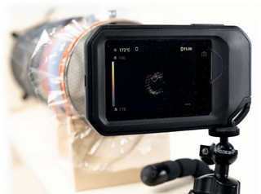
Experiment: Absorption of heat radiation
Materials:

✓ same materials as above
✓ thermal imaging camera with static

Achtung! Sehr heißer Strahler: Verbrennungsgefahr!

Preperations:
- For this experiment, carefully open the protective cage (risk of burns!) so that there is no grid between the infrared emitter and the cardboard tube. Mount the thermal imaging camera on the stand so that the heat radiation hits the measuring opening of the thermal imaging camera through the cardboard tube and the target cross is on the heat emitter.
- → Addition for thermal imagers with fixable temperature scale (e.g. FLIR C3-X): Set the temperature scale to manual, fix the upper limit (maximum temperature of the heat emitter) and then set the lower limit approximately 20°C below it.

Implementation:
- Wait until the temperature remains constant (as above) and then observe the temperature reading (and visible image, if applicable) of the thermal imaging camera as CO2 is poured into the cardboard tube.

Task:
- Interpret the result! Note that a thermal imaging camera calculates the temperature of an object using the emitted thermal radiation (see Activity 4 - Stefan-Boltzmann law).

Part 2: Why do greenhouse gases in the atmosphere heat up the Earth's surface?
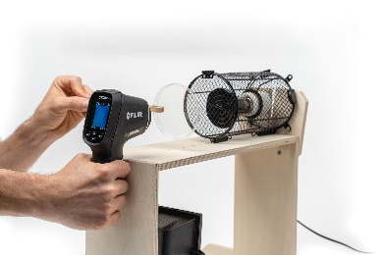
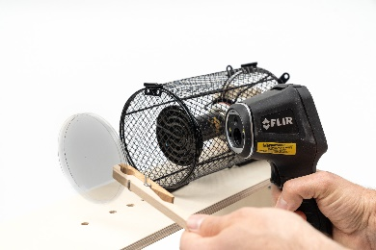
Materials:
Absorption Model atmosphere
Reflection Model atmosphere
Ceramic infrared radiator
Petri dish out of glass
Wooden clip
Thermal imaging camera
Implementation:
The Petri dish out of glass in the following experiment acts like a very dense greenhouse gas atmosphere that absorbs almost all the infrared radiation from the Earth's surface (infrared radiator). Observe the infrared radiator from the front with the thermal imaging camera, first without the glass plate and then push the glass plate in between with the help of wooden clip (left picture). Observe for about one minute and then write down your observations.
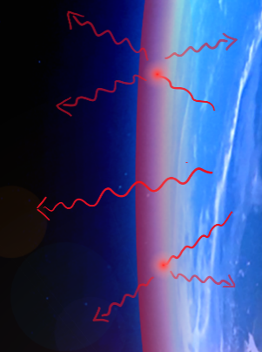
Now look (directly afterwards) at the glass plate from the surface of the Earth (right picture). The effect observed here in the model experiment is a further crucial element in understanding the greenhouse effect. Explain it by putting the sentence blocks in the right order:
Reflection of IR radiation by the atmosphere
- It is heated up by absorbing radiant energy.
- The greenhouse gas CO₂ absorbs the heat radiation emitted from the Earth.
- This additional source of radiation heats up the Earth's surface.
- The heated gas itself now radiates infrared radiation in all directions, including towards the Earth.

