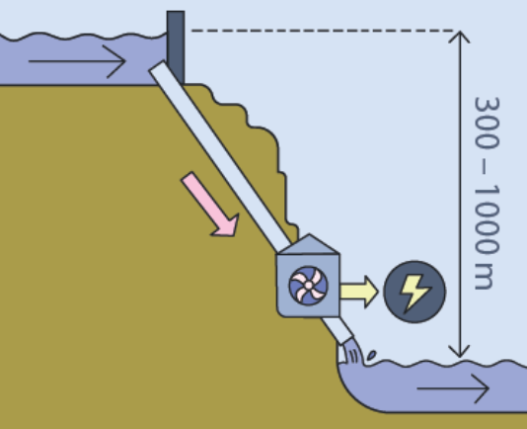
Energy generation in a hydropower station
#energy_sources #conversion_water_volume_mass #E_{pot}=m·g·h
#conversion_kWh-J #efficiency #Energy_Conversions_Power_Station
Hydropower - Worksheet 1 - Page 1 of 2

- Here you can see a schematic diagram of a hydropower station.
- Explain the purpose and function of such a power station.

- List all the energy conversions which occur.

- In Lake “Walchensee” there are $13⋅{10}^{8} m^{3}$ of water. From there, $7,3⋅{10}^{6}{ m}^{3}$ per day rush through the turbines into Lake “Kochelsee“. That has a water volume of $184⋅{10}^{6}{ m}^{3}$.

- Write out all the given quantities and mark the ones you need to calculate the potential energy E_{pot} (position energy).

- Explain why the given information is not sufficient to calculate the energy.

- The difference in height between the two lakes is 200 m. Assume that $\frac{1}{4}$ of the energy is converted into heat at the turbine. Calculate the maximum electrical energy that the Walchensee-power-station can supply per day. Tip: If you don't remember how to convert the volume of water into mass or how to convert the unit J (joule) into the unit kWh (kilowatt hour), look at help card 1.
Hydropower - Worksheet 1 - Page 2 of 2

- In reality, the power station produces an amount of electrical energy of approximately $300⋅{10}^{6} kWh$ per year. Compare the value calculated in task 3 with the actual value. Justify this difference.

Help card:
$$1 J=1Ws=1 ∙{10}^{-3} kW s= 1∙{10}^{-3} kW ∙\frac{1}{60∙60} h= 2,78⋅{10}^{-7} kWh$$
Calculating the mass of water: $1{ m}^{3}=1000 dm^{3}=1000 l≙1000 kg=1⋅{10}^{3} kg=1 t$

Energy generation in a hydropower station – Solutions
#energy_sources #conversion_water_volume_mass #E_{pot}=m·g·h
#conversion_kWh-J #efficiency #Energy_Conversions_Power_Station

Solutions for Hydropower - Worksheet 1 - Page 1 of 2

- Here you can see a schematic diagram of a hydropower station.
- Explain the purpose and function of such a power station.
The aim of a power station is to provide energy in the form of electricity.

In a storage hydropower station, water is first dammed in a higher lake and then released into a lower lake via downpipes as needed. Turbines and generators are powered in the process.

- List all the energy conversions which occur.
Conversion of positional energy (water in a higher lake) into kinetic energy (water in the downpipes).
Conversion into kinetic energy by the turbine and generator
Conversion into electrical energy
(additional conversion to thermal energy in each conversion process).

- In Lake “Walchensee” there are $13⋅{10}^{8} m^{3}$ of water. From there, $7,3⋅{10}^{6}{ m}^{3}$ per day rush through the turbines into Lake “Kochelsee“. That has a water volume of $184⋅{10}^{6}{ m}^{3}$.

- Write out all the given quantities and mark the ones you need to calculate the potential energy E_{pot} (position energy).
V _{lake top} = $13⋅{10}^{8} m^{3}$ g = 9,81 $\frac{N}{kg}$
V _{turbines} = $7,3⋅{10}^{6}{ m}^{3}$
V _{lake bottom} = $184⋅{10}^{6}{ m}^{3}$.
The details of the water quantities in the lakes are unimportant. The important aspect is the amount of water that flows through the turbines (mass of water).

- Explain why the given information is not sufficient to calculate the energy.
The height difference h between the lakes is missing: $E_{pot}=m⋅g⋅h$.
- The difference in height between the two lakes is 200 m. Assume that $\frac{1}{4}$ of the energy is converted into heat at the turbine. Calculate the maximum electrical energy that the Walchensee-power-station can supply per day. Tip: If you don't remember how to convert the volume of water into mass or how to convert the unit J (joule) into the unit kWh (kilowatt hour), look at help card 1.
Solutions for Hydropower - Worksheet 1 - Page 1 of 2

geg.: V _{turbines} = $7,3⋅{10}^{6}{ m}^{3}$ ${ m}_{water}=7,3⋅{10}^{9} kg$; $h=200 m$; $g=9,81\frac{N}{kg}$
ges.: $E_{pot}$
Lsg.: $E_{pot}=m⋅g⋅h$
$$E_{pot}=7,3⋅{10}^{9}kg⋅9,81\frac{N}{kg} ⋅200 m$$
$$E_{pot}=1,4⋅{10}^{13}J= 4,0⋅{10}^{6} kWh$$
$\frac{1}{4}$ thereof: $W_{th}=1,0⋅{10}^{6} kWh$
$$E_{el}=E_{pot}-W_{th}=4,0⋅{10}^{6} kWh-1,0⋅{10}^{6} kWh=3,0⋅{10}^{6} kWh$$
Alternatively over $η=1-\frac{1}{4}=\frac{3}{4}=0,75$ :

$$E_{el}=0,75⋅E_{pot}=0,75⋅4,0⋅{10}^{6}kWh= 3,0⋅{10}^{6}kWh$$

- In reality, the power station produces an amount of electrical energy of approximately $300⋅{10}^{6} kWh$ per year. Compare the value calculated in task 3 with the actual value. Justify this difference.
$E_{el per day}=300⋅{10}^{6}kWh :365=822⋅{10}^{3}kWh=0,822⋅{10}^{6}kWh$ ≪ $3,0⋅{10}^{6} kWh$

The maximum possible yield is about four times the actual output.
The hydropower station is a demand power station and does not operate at full load all year round. The amount of water flowing through the turbines is also limited in order to avoid affecting the ecosystem.

Help card:
$$1 J=1Ws=1 ∙{10}^{-3} kW s= 1∙{10}^{-3} kW ∙\frac{1}{60∙60} h= 2,78⋅{10}^{-7} kWh$$
Calculating the mass of water: $1{ m}^{3}=1000 dm^{3}=1000 l≙1000 kg=1⋅{10}^{3} kg=1 t$

Energy generation in a
Supplementary notes on hydropower - Worksheet 1
Notes on the sources and estimations

hydropower station

2) bis 4)
The volume data of the lakes are referenced from this document:
https://www-docs.b-tu.de/fg-gewaesserschutz/public/projekte/uba_2/11_bayern.pdf
- Maximum flow rate $84\frac{m³}{s}=84 ⋅24⋅3600\frac{m^{3}}{d}=7,3⋅{10}^{6}\frac{m^{3}}{d}=7,3⋅{10}^{9}\frac{l³}{d}$
This information can be found in the booklet on Walchensee under www.uniper.energy/sites/default/files/2022-08/Brosch%C3%BCre%20Kraftwerk%20Walchensee.pdf by the energy supplier Uniper, which provides quite beautiful pictures for teaching.

- The yield amount is also taken from the operator booklet.
- The height and pipe length are taken from Wikipedia.

- The power station is criticised because it disrupts the natural course of the Isar. This causes animals and plants to be displaced and the Isar gets a lower water level. This shows that hydropower also has ecological consequences.

