Energy generation in a hydropower station
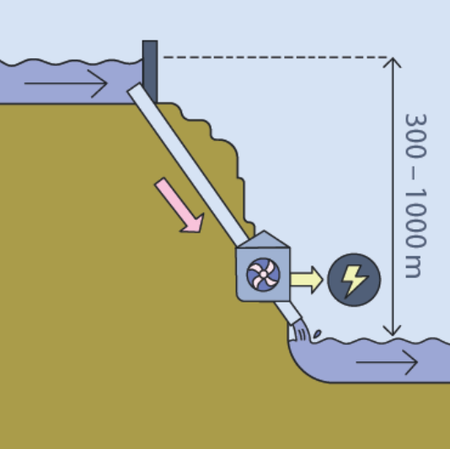
Task 1:
Here you can see a schematic diagram of a hydropower station.
Explain the functioning of such a power plant, taking into account the energy conversions.

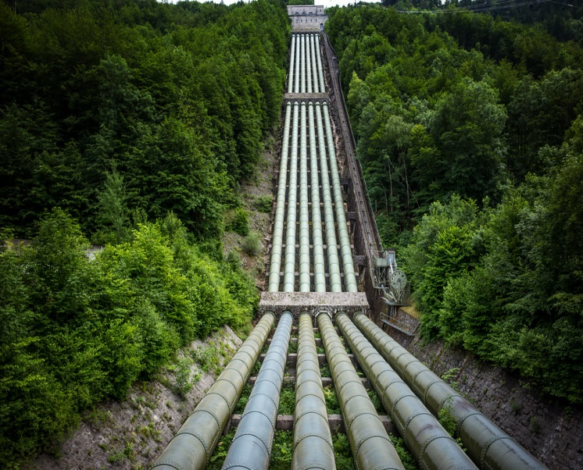
Task 2:

"This photo" by unknown author is licensed under CC BY-NC
In Lake “Walchensee” there are approximately $1299⋅{10}^{6}m^{3}$ of water. From there, a maximum of $7,3⋅{10}^{6}m^{3}$ per day rushes through the turbine into the $184⋅{10}^{6}m^{3}$ of water in Lake “Kochelsee”.
Assess the relevance of the variables to estimate the amount of energy that the Walchensee-power-station could produce theoretically.
Explain why the given information is not sufficient to calculate the energy.

Task 3:
Calculate the maximum electrical energy that the Walchensee-power-station can supply per day. Assume that $\frac{1}{4}$ of the energy is converted into heat at the turbine. The mass of $m^{3}$ of water and the conversion from J to kWh can be found on help card 2.

Task 4 (optional):
Compare the value calculated in task 3 with the actual value produced by the power station per year. Evaluate the relevance of efficiency in the estimation.
The yearly amount of generated energy can be found on help card 3.

Energy generation in a hydropower station (guided version)
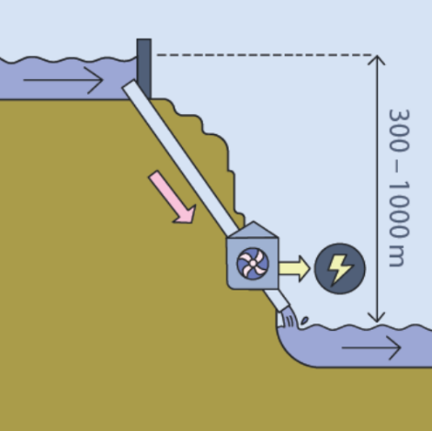
Task 1:
Here you can see a schematic diagram of a hydropower station.
Which energy form conversions do you recognize?
________________________________________________
Write down the aim of such a power station as precisely as possible.
___________________________________________________
___________________________________________________
Task 2:

"This photo" by unknown author is licensed under CC BY-NC

In Lake “Walchensee” there are approximately $1299⋅{10}^{6}m^{3}$ of water. From there, a maximum of $7,3⋅{10}^{6}m^{3}$ per day rushes through the turbine into the $184⋅{10}^{6}m^{3}$ of water in Lake “Kochelsee”.
Select which of these is relevant to estimate the amount of energy that the hydropower station could theoretically produce?
____________________________________
Which quantity out of the figure is missing? Compare with the help card 1.
____________________________________

Task 3:
Using the information on help card 1, calculate the maximum electrical energy that the Walchensee-power-station can supply per day. The mass of $m^{3}$of water and the conversion from J to kWh can be found on help card 2.

Task 4 (optional):
What energy does the power station produce in a year using the estimation from task 3?
You can find the actual amount of energy produced annually on help card 3. Where does this difference come from?

Help card 1:
The difference in height of the lakes is about 200m. Wikipedia says that the pipes are 430m long. Think about which of the statements is most relevant.
Help card 2:
$1J=2,78⋅{10}^{-7}kWh$
Mass of water: $1m^{3}=1⋅{10}^{3}kg$

Help card 3:
The amount of energy produced annually by the Walchensee-power-station is approximately $300⋅{10}^{6}kWh$.

Solutions
Task 1: The aim of a hydropower station is providing energy in the form of electricity.
This occurs by converting positional energy (of the water at a higher level) into kinetic energy of the water in the drop tubes and then by converting it into electrical energy in the turbines.
Task 2: The information on the water quantities in the lakes is irrelevant. What matters is the amount of water that flows through the turbines (mass of water). However, the difference in height between the lakes is missing -> $E_{pot}=m⋅g⋅h$.
See below for references to the sources.
Task 3:
Geg.: $m_{water}=7,3⋅{10}^{9}kg$; $h=200m$
$$E_{pot}=m⋅g⋅h$$
$$E_{pot}=7,3⋅{10}^{9}kg⋅200 m⋅9,81\frac{m}{s^{2}}$$
$$E_{pot}=1,4⋅{10}^{13}J≈3,9⋅{10}^{6}kWh$$
Alternatively over $η$: $⇒E_{el}=0,75⋅E_{pot}=0,75⋅3,9⋅{10}^{6}kWh≈3⋅{10}^{6}kWh$
Task 4:
Annual maximum energy yield according to task 3: $E_{pot,jährl}=3,9⋅{10}^{6}kWh⋅365=1,42⋅{10}^{9}kWh$
Alternatively over $η$: $E_{pot,annually}=3⋅{10}^{6}kWh⋅365=1,1⋅{10}^{9}kWh$
Yield according to the manufacturer: $300⋅{10}^{6}kWh$=$0,3⋅{10}^{9}kWh$
The annual yield is about a factor of $5 (alt.: \sim 4)$ less than the highest possible yield. The hydropower station is a demand power station and does not operate at full load all year round. The amount of water flowing through the turbines is also limited in order to avoid affecting the ecosystem, see below.
The efficiency of the power station has no real relevance because, as a demand power station, it supplies less electrical energy than would be possible at maximum.
Notes on the sources and estimations:
The water quantity of the lakes “Walchensee” and “Kochelsee” are irrelevant for the task.
The volume data of the lakes are referenced from this document “Dokumentation von Zustand und Entwicklung der wichtigsten Seen Deutschlands: Teil 11 Bayern“
- Maximum flow rate $84\frac{m³}{s}=84 ⋅24⋅3600\frac{m^{3}}{d}=7,3⋅{10}^{6}\frac{m^{3}}{d}=7,3⋅{10}^{9}\frac{l³}{d}$
This information can be found in the booklet by the energy supplier Uniper, which provides quite beautiful pictures for teaching.
- The yield amount is also taken from the operator booklet.
- The height and pipe length are taken from Wikipedia..

The power station is criticized because it disrupts the natural course of the Isar. This causes animals and plants to be displaced and the Isar gets a lower water level.
This shows that hydropower also has ecological consequences.

